1. Project Overview
This project analyzes the Northwind Traders dataset using Power BI to uncover insights related to sales, customers, products, employees, and suppliers. The goal is to transform raw data into meaningful dashboards for decision-making.

2. Objective
- Analyze sales performance
- Understand customer behavior
- Identify top products and categories
- Evaluate supplier and employee insights
- Build an interactive dashboard

3. Significance
Power BI enables converting raw data into interactive dashboards and insights for better business decisions

4. Data Dictionary
- Customers → customer_id, country
- Orders → order_id, order_date
- Order Details → quantity, unit_price, discount
- Products → product_name, category
- Employees → employee_id, title
- Suppliers → supplier_name, country

5. ER Diagram
- Fact: Orders, Order Details
- Dimensions: Customers, Products, Employees, Suppliers
- Relationships: One-to-Many 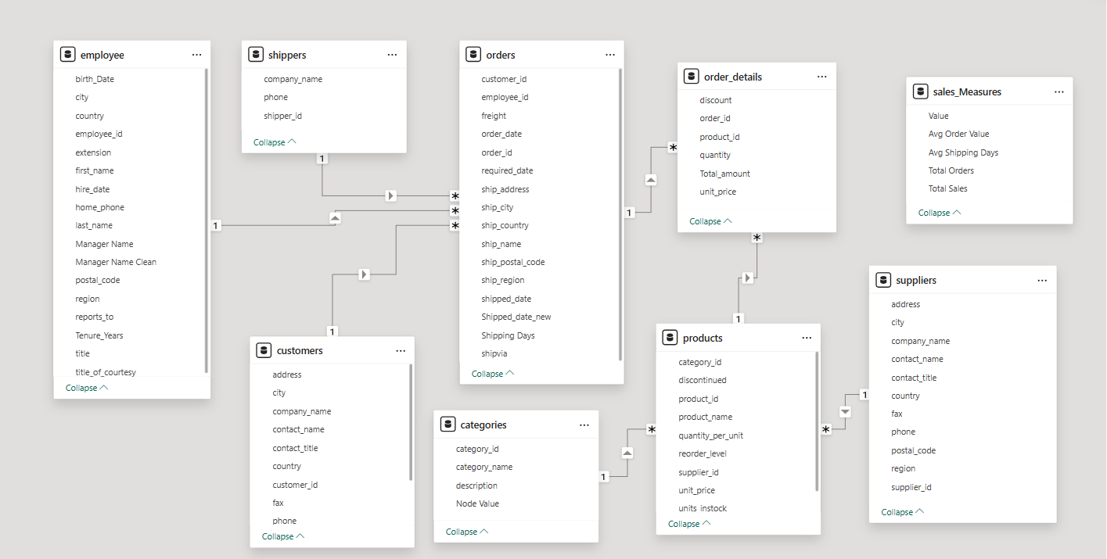

6. Steps to Connect Data
- Open Power BI
- Click Get Data → CSV/Excel
- Load tables
- Create relationships in Model View
- Clean data in Power Query

7. Problem Statement, Solution & Insights
Problem: Lack of visibility into sales and performance
Solution: Built dashboard with KPIs and visuals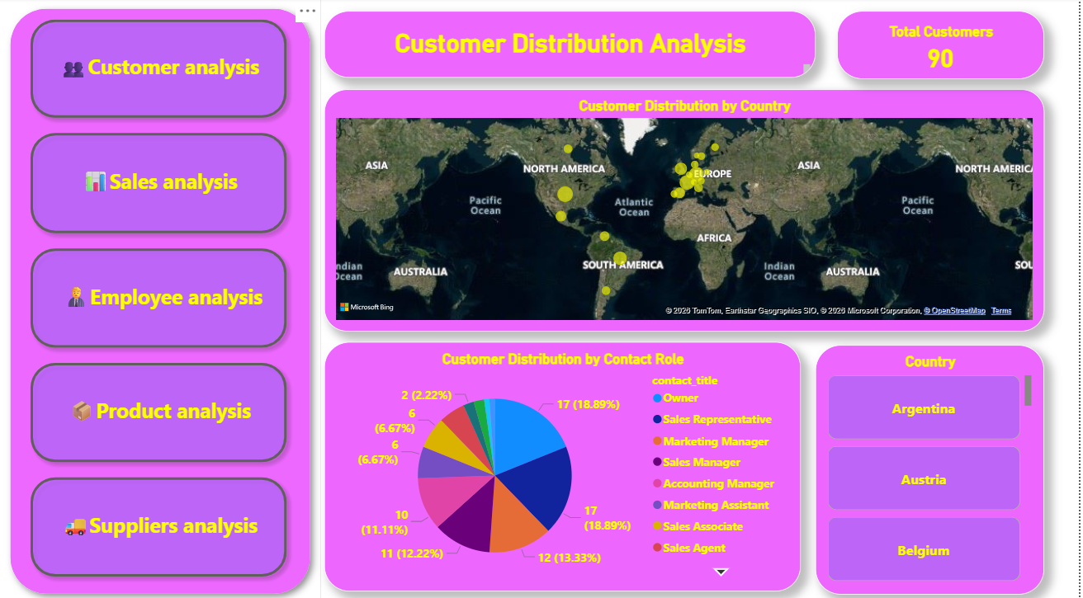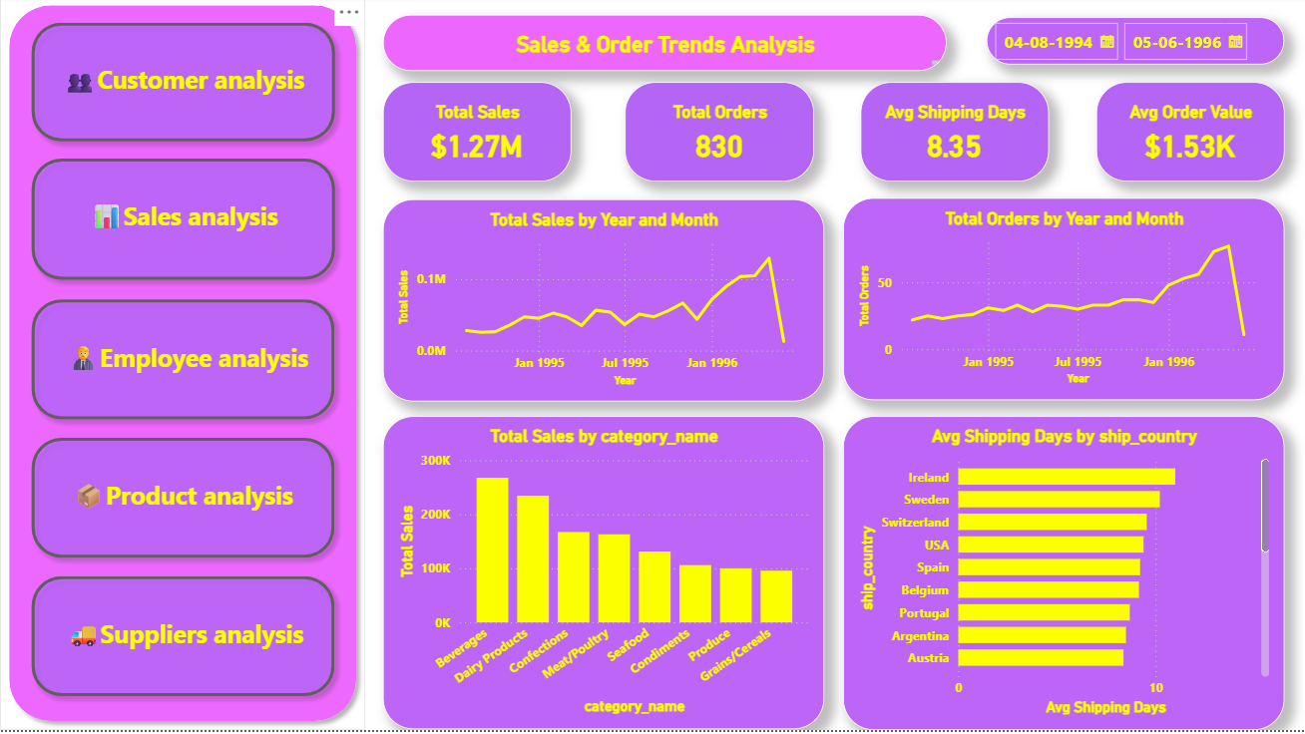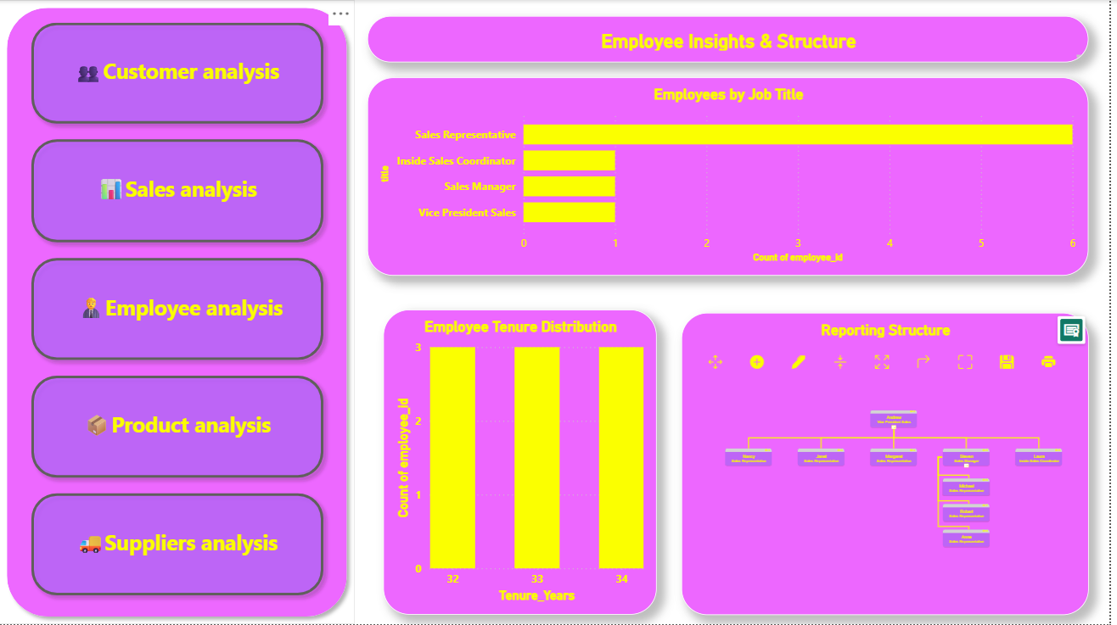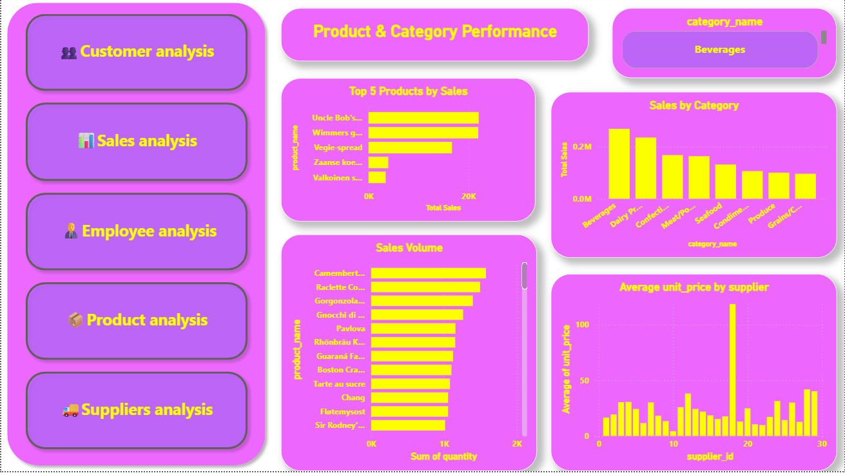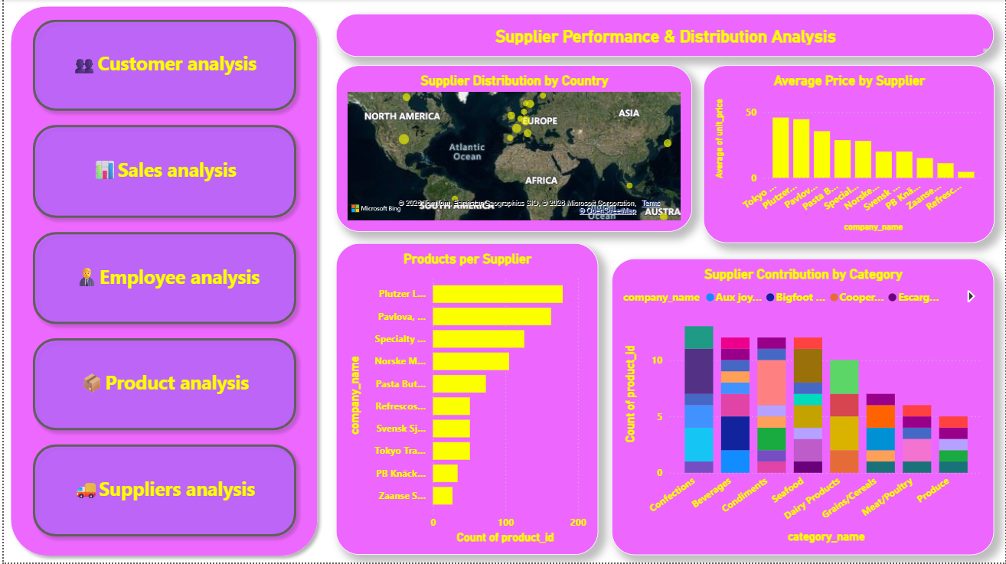
Insights:
- Sales increasing over time
- Top products drive revenue
- Customers concentrated in key regions

8. Conclusion
The project provides actionable insights into business performance and supports data-driven decision-making using Power BI dashboards

